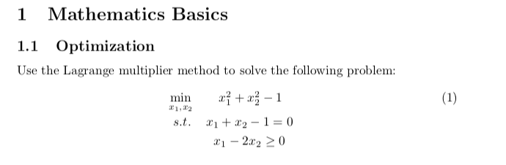

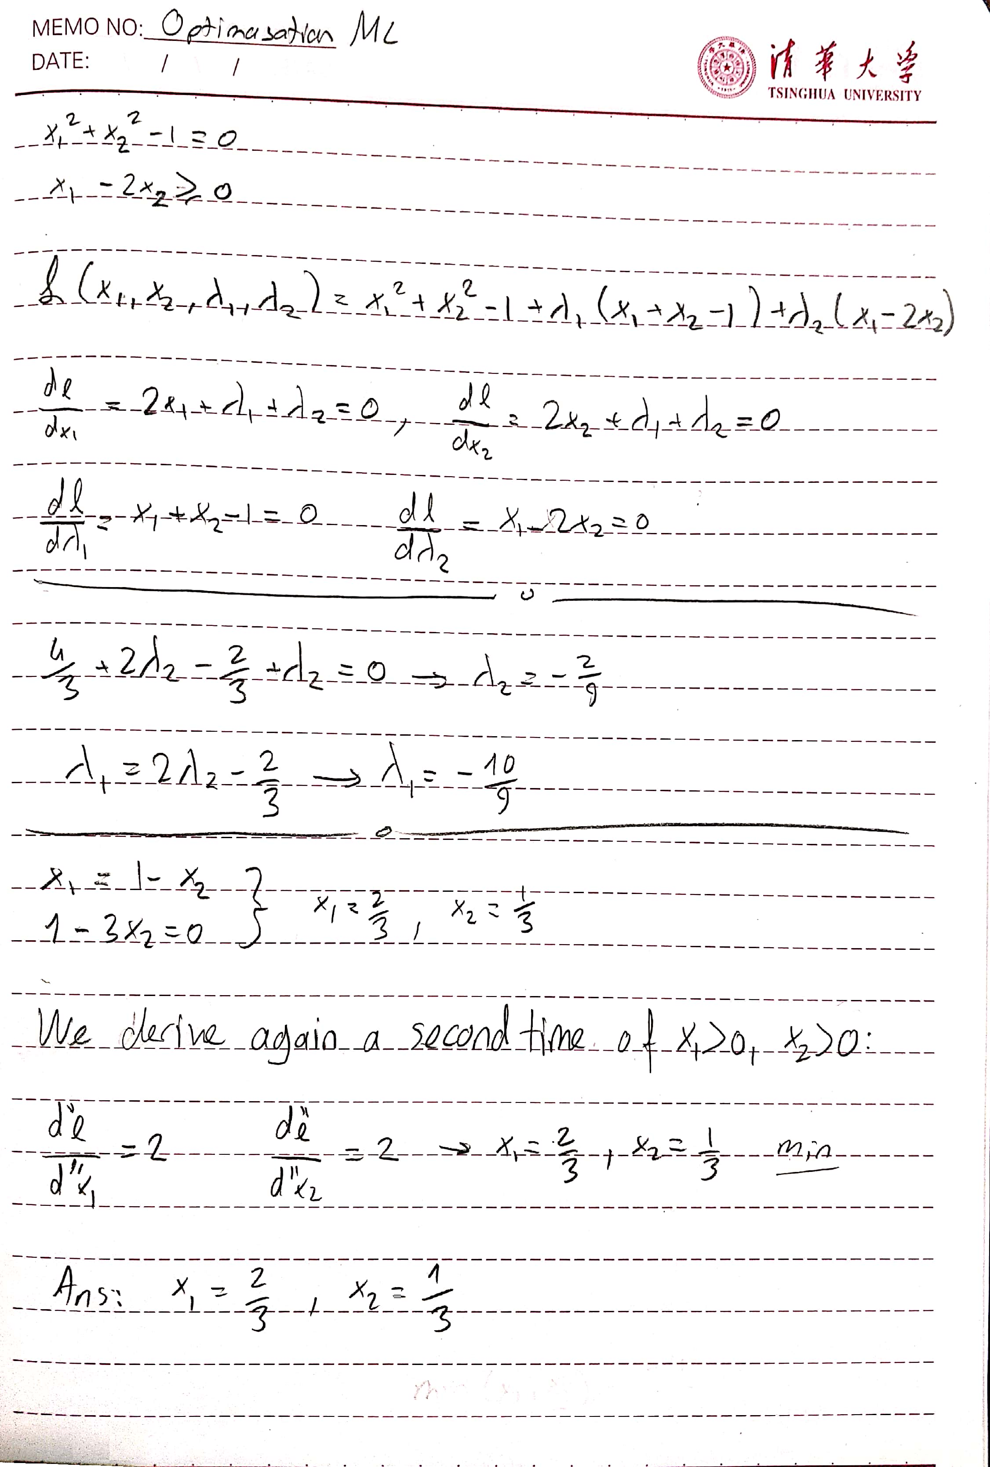

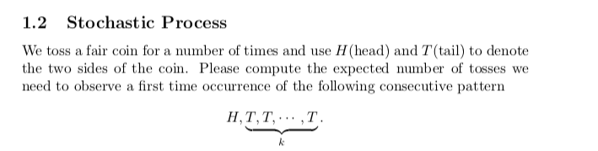

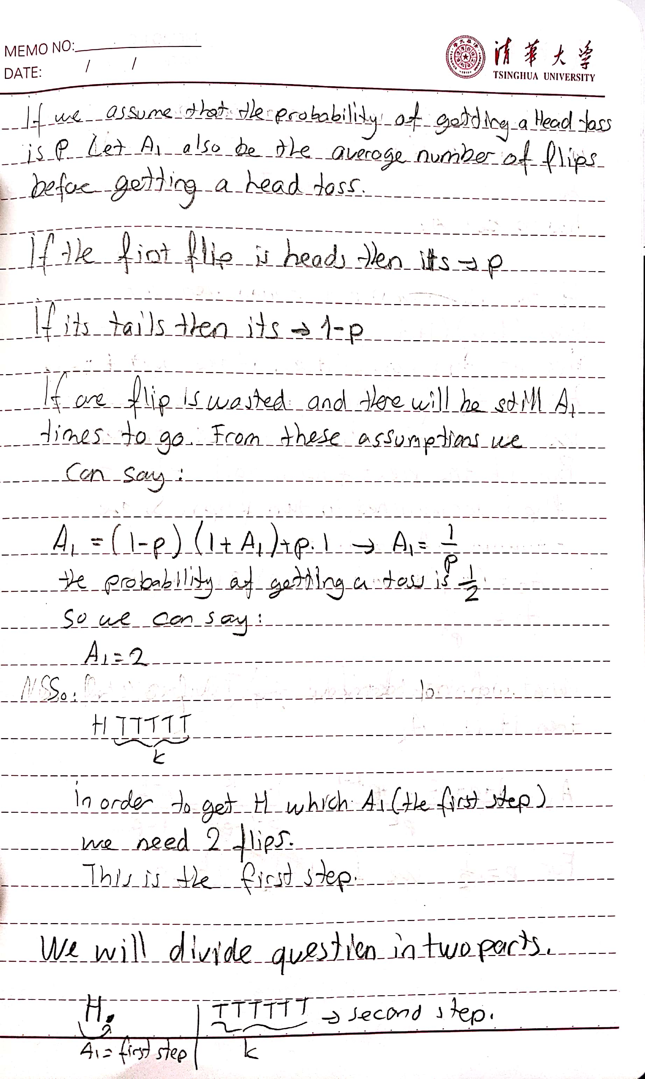

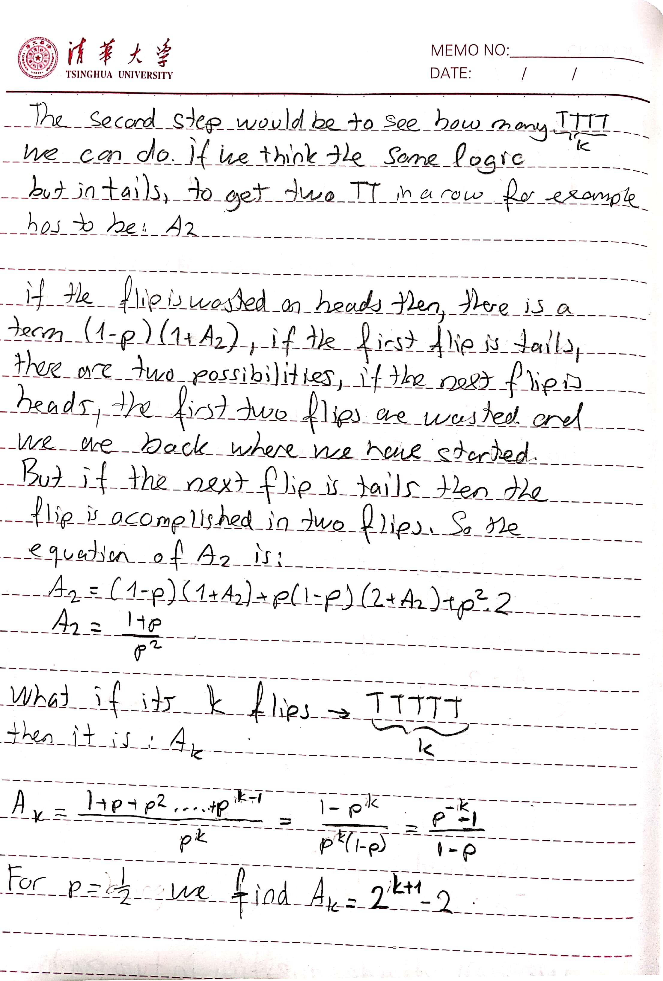

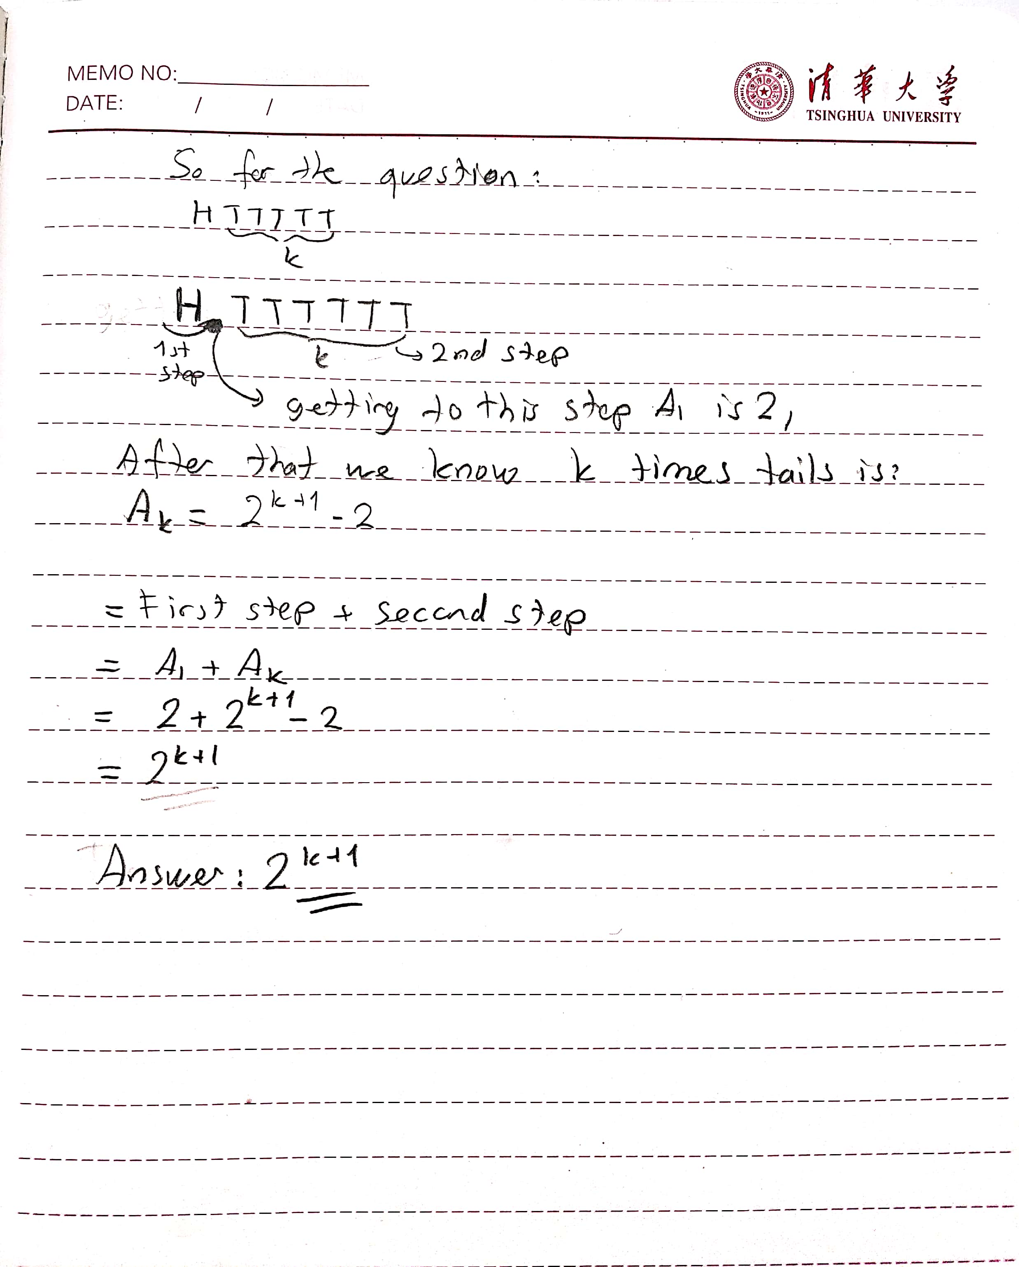

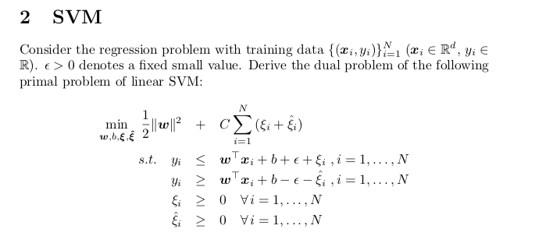

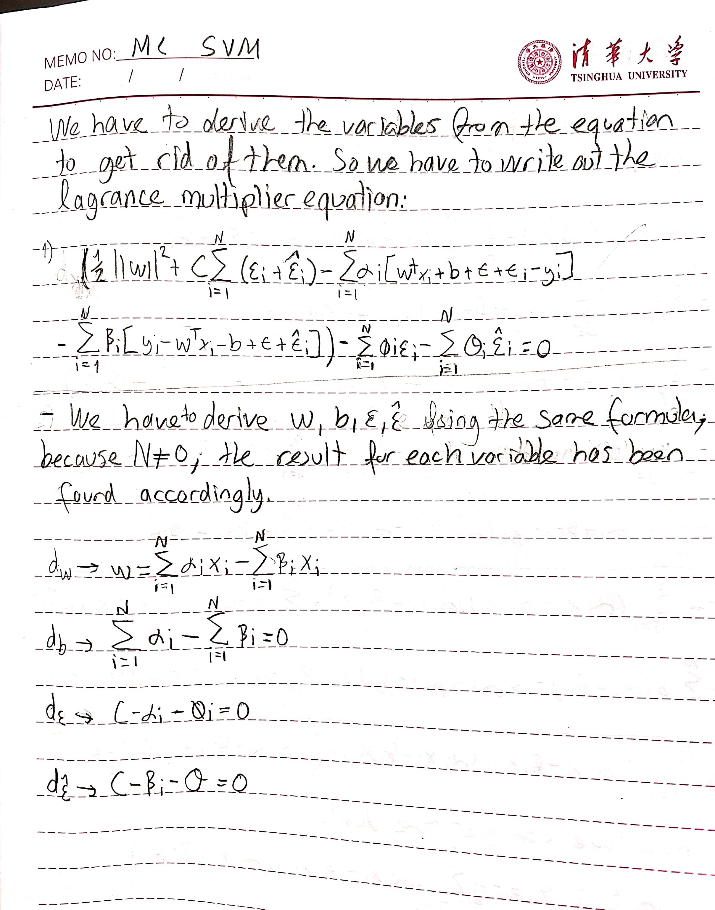

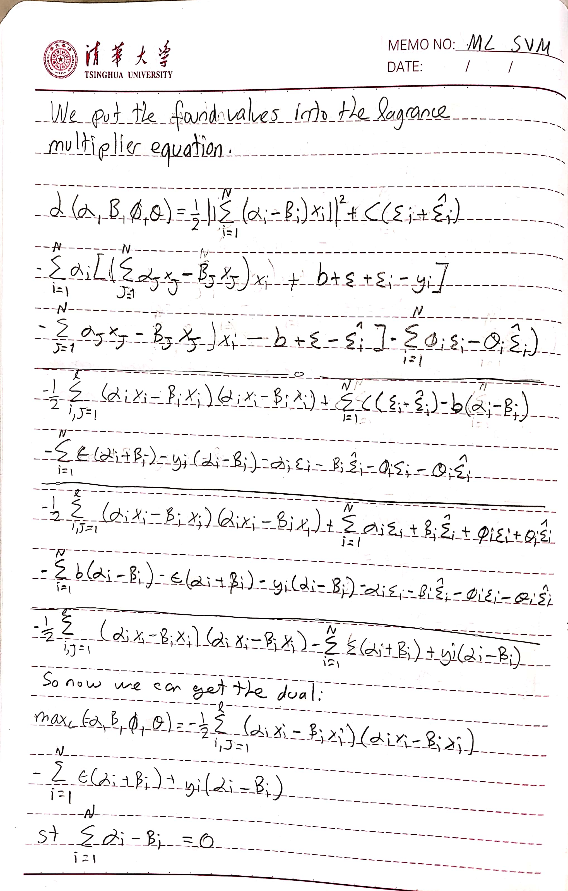

3. Deep Neural Networks

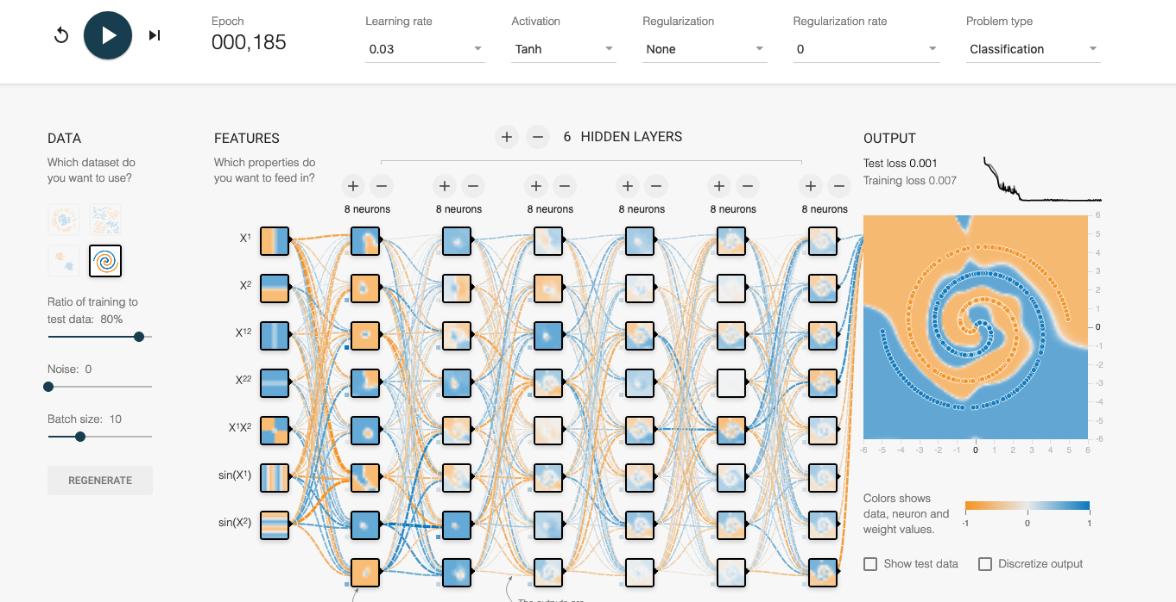

Tweaking with the Neural Network playground. I have found that the more neurons, hidden layers and features I have added, the training loss decreased each time. Also increasing training test ratio to 80% decreased the test loss. I have tried Tanh and Relu as it is good for keeping the non-linearity. It would be really hard to train with given data with linear.

4 IRLS for Logistic Regression

Code

In [46]:

**import numpy as np import tensorflow as tf**

**from sklearn.datasets import** load_svmlight_file

In [47]: **def** shaping_the_data(x_training, x_testing, y_training, y_testing):

n_training = x_training.shape[0] n_testing = x_testing.shape[0]

x_training = np.hstack((np.ones((n_training, 1)), x_training.toarray())) x_testing = np.hstack((np.ones((n_testing, 1)), x_testing.toarray()))

y_training = y_training.reshape((n_training, 1)) y_testing = y_testing.reshape((n_testing, 1))

y_training = np.where(y_training == -1, 0, 1)

y_testing = np.where(y_testing == -1, 0, 1)

**return** x_training, x_testing, y_training, y_testing

**def** log_likelihood(w, x, y, L2_lamda=0):

res = tf.matmul(tf.matmul(tf.transpose(w), tf.transpose(x)), y)

- tf.reduce_sum(tf.log(1 + tf.exp(tf.matmul(x, w)))) res += -0.5 * L2_lamda * tf.norm(w)

**return** -res[0][0]

**def** soft_max_func(x, w):

y = tf.constant(np.array([0., 1.]), dtype=tf.float32)

proba = tf.exp(tf.matmul(x, w) * y) / (1 + tf.exp(tf.matmul(x, w)))

**return** proba

**def** score(x, y, w):

p = soft_max_func(x, w)

y_pred = tf.cast(tf.argmax(p, axis=1), tf.float32) y = tf.squeeze(y)

acc = tf.reduce_mean(tf.cast(tf.equal(y, y_pred), tf.float32))

**return** acc

**def** optimize(w, w_update):

**return** w.assign(w - w_update)

**def** update(w, x, y, L2_lamda=0):

mul = tf.sigmoid(tf.matmul(x, w)) R_flat = mul * (1 - mul)

dim = x.shape.as_list()[1] L2_reg_term = L2_lamda * tf.eye(dim)

xRx = tf.matmul(tf.transpose(x), R_flat * x) + L2_reg_term S, U, V = tf.svd(xRx, full_matrices=**True**, compute_uv=**True**) S = tf.expand_dims(S, 1)

S_pinv = tf.where(tf.not_equal(S, 0), 1 / S, tf.zeros_like(S)) xRx_pinv = tf.matmul(V, S_pinv * tf.transpose(U))

w_update = tf.matmul(xRx_pinv, tf.matmul(tf.transpose(x), mul - y) + L2_lam da * w)

**return** w_update

In [48]: **if** name

== " main ":

x_training, y_training = load_svmlight_file("a9a", n_features=123, dtype=n p.float32)

X_test, y_test = load_svmlight_file("a9a.t", n_features=123, dtype=np.float

32)

x_training, X_test, y_training, y_test =shaping_the_data(x_training, X_tes

t, y_training, y_test) L2_lamda = 30

N, dim = x_training.shape

X = tf.placeholder(dtype=tf.float32, shape=(**None**, 124), name="x") y = tf.placeholder(dtype=tf.float32, shape=(**None**, 1), name="y")

w = tf.Variable(0.01 * tf.ones((dim, 1), dtype=tf.float32), name="w") w_update = update(w, X, y, L2_lamda)

loss = log_likelihood(w, X, y, L2_lamda) acc = score(X, y, w)

optimize_op = optimize(w, w_update)

**se**)

config = tf.ConfigProto(allow_soft_placement=**True**, log_device_placement=**Fal**

session = tf.Session(config=config) session.run(tf.global_variables_initializer())

max_iter = 100

**for** i **in** range(1, max_iter): print("iteration: **{}**".format(i)) print("**\n**")

print("log likelihood: **{}**".format(session.run(loss, feed_dict={X: x_tra ining, y: y_training})))

train_acc = session.run(acc, feed_dict={X: x_training, y: y_training}) test_acc = session.run(acc, feed_dict={X: X_test, y: y_test})

print("test data accuracy score: **{}**,**\n**training data accuracy score:

**{}**".format(test_acc, train_acc))

L2_norm_w = np.linalg.norm(session.run(w)) print("L2-norm of |w|2: **{}**".format(L2_norm_w)) print("**\n**==============================================================")

deri_w = np.linalg.norm(session.run(w_update, feed_dict={X: x_training, y: y_training}))

g})

**if** deri_w < 0.001:

**break**

w_new = session.run(optimize_op, feed_dict={X: x_training, y: y_trainin

print("End of Iteration.")

**Results**

iteration: 1

log likelihood: -1169.1973876953125

test data accuracy score: 0.23622627556324005, training data accuracy score: 0.24080955982208252

L2-norm of |w|2: 0.11135528236627579

==============================================================

iteration: 2

log likelihood: -906.0789794921875

test data accuracy score: 0.8458325862884521, training data accuracy score: 0.8442308306694031

L2-norm of |w|2: 2.0898401737213135

==============================================================

iteration: 3

log likelihood: -1882.44189453125

test data accuracy score: 0.8495792746543884, training data accuracy score: 0.8468105792999268

L2-norm of |w|2: 3.069146156311035

==============================================================

iteration: 4

log likelihood: -2360.68408203125

test data accuracy score: 0.8506848216056824, training data accuracy score: 0.847179114818573

L2-norm of |w|2: 3.6801035404205322

==============================================================

iteration: 5

log likelihood: -2470.489501953125

test data accuracy score: 0.8509305119514465, training data accuracy score: 0.8476091027259827

L2-norm of |w|2: 3.954674482345581

==============================================================

iteration: 6

log likelihood: -2475.976318359375

test data accuracy score: 0.8511762022972107, training data accuracy score: 0.8476705551147461

L2-norm of |w|2: 4.0110764503479

==============================================================

iteration: 7

log likelihood: -2475.8369140625

test data accuracy score: 0.8511762022972107, training data accuracy score: 0.8476705551147461

L2-norm of |w|2: 4.013559341430664

==============================================================

End of Iteration.